Table S1: Hemoglobin concentration and anemia prevalence using HemoCue® and automated hematology analyzers individually
 | Hospital-based automated hematology analyzer |  |  | Field-based automated hematology analyzer
 | HemoCue® Hb301 | XT-1800, Sysmex | p-value | HemoCue® Hb301 | BC-3000Plus, Mindray Med. Internat. Ltd | p-value
Participants*, n (%) | 633 (42.6) |  |  | 854 (57.4)
Hb (mean ± SD), g/L | 110.7 ± 9.7 | 107.4 ± 12.5 | <0.0001 | 106.7 ± 10.4 | 98.4 ± 12.2 | <0.0001
Anemia prevalence, % | 46.0 | 59.4 | <0.0001 | 59.5 | 84.7 | <0.0001
Bias (95% limits of agreement) | 3.2 (-14.1, 20.5) |  |  | 8.3 (-8.4, 24.9)
r (Correlation coefficient) | 0.71 |  | <0.0001 | 0.73 |  | <0.0001
Sensitivity, % | 69.4 |  |  | 66.8
Specificity, % | 88.3 |  |  | 80.9

*Each comparison is done in a different sub-group of children

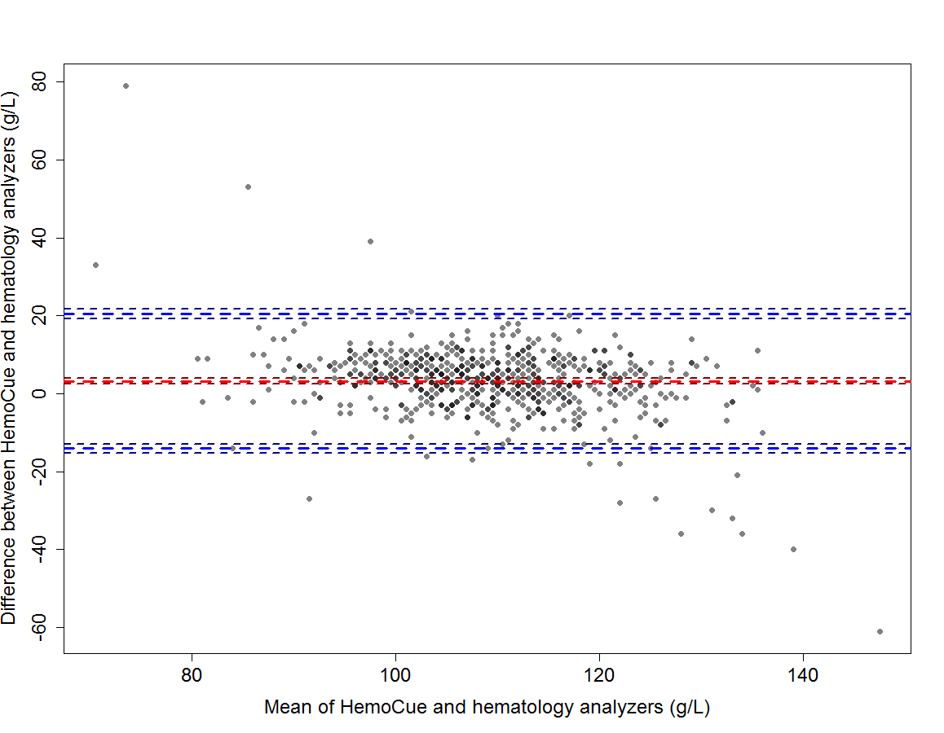
Figure S1: Bland-Altman plot showing agreement in hemoglobin concentration assessed by HemoCue®Hb301 and by the automated hematology analyzer XT-1800 by Sysmex

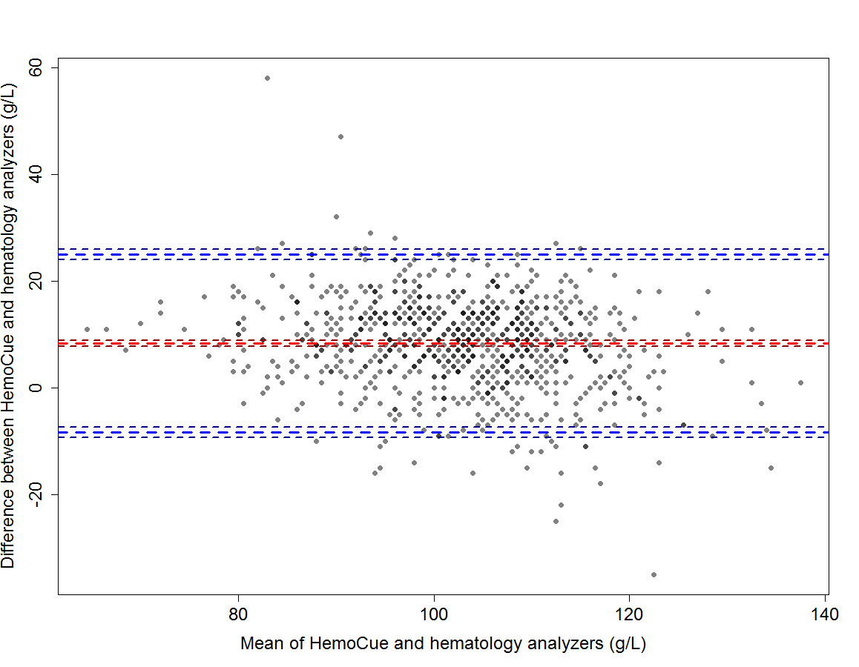
Figure S2: Bland-Altman plot showing agreement in hemoglobin concentration assess by HemoCue®Hb301 and BC-3000Plus, Mindray automated hematology analyzer

Table S2: Hemoglobin concentration and anemia prevalence by age groups in young Laotian children using two different methods of assessment
Age, months | N | Hemoglobin (mean ± SD), g/L |  |  |  | Anemia prevalence n (%)
 |  | HemoCue® Hb301 | Automated analyzers* | p-value | Bias (95% CI), g/L | HemoCue® Hb301 | Automated analyzers* | p-value
6-11 | 523 | 106.2 ± 10.2 | 98.9 ± 12.2 | <0.0001 | 7.3 (6.6-8.0) | 318 (60.8) | 436 (83.4) | <0.0001
12-17 | 502 | 107.8 ± 10.0 | 101.9 ± 13.6 | <0.0001 | 5.9 (5.1-6.7) | 286 (57.0) | 286 (73.5) | <0.0001
18-24 | 462 | 111.4 ± 9.9 | 106.5 ± 12.4 | <0.0001 | 5.0 (4.1-5.8) | 195 (42.2) | 195 (63.6) | <0.0001
* XT-1800i by Sysmex and BC-3000Plus by Mindray Medical International Ltd
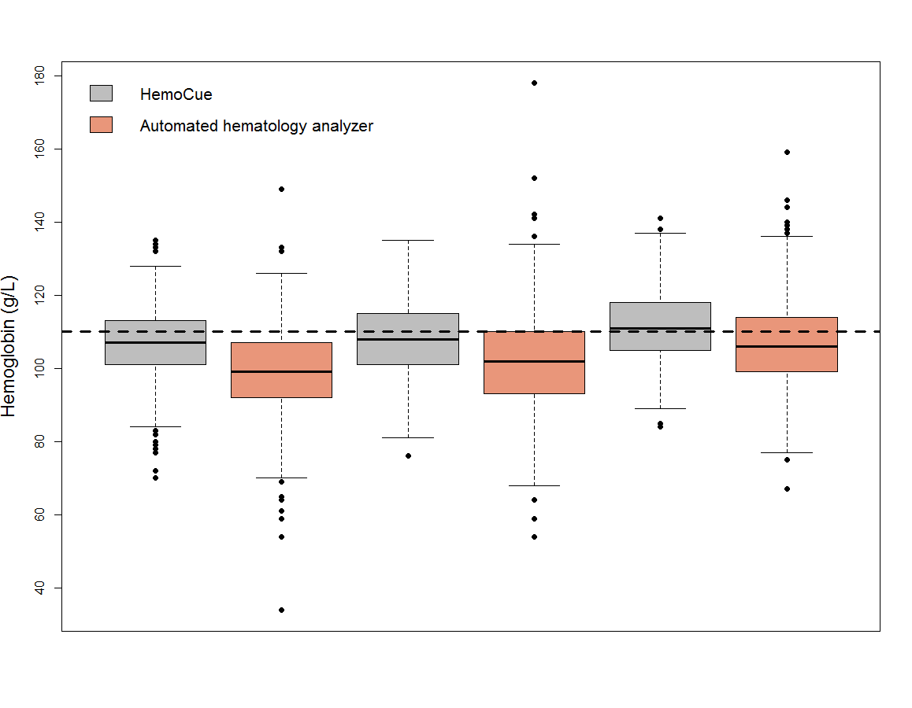
18-24 mo
12-17 mo
06-11 mo
Figure S3: Box plots comparing the distribution of hemoglobin levels by age group using HemoCue®Hb301 and the automated analyzers combined (XT-1800i by Sysmex and BC-3000Plus by Mindray Medical International Ltd).
*Dash line represents the Hb cut-off value for anemia in children of 6-59 months of age (Hb < 110g/L)

Table S3: Hb measurements provided by the three different HemoCue® Hb301 devices

 | HemoCue® #1 Vs HemoCue® #2 | HemoCue® #1 Vs HemoCue® #3 | HemoCue® #2 Vs HemoCue® #3
Hb (mean ± SD), g/L | 112.9 ± 8.8 vs 113.2 ± 6.9 | 112.9 ± 8.8 vs 117.1 ± 9.4 | 113.2 ± 6.9 vs 117.1 ± 9.4
Difference (95% CI), g/L | -0.3 (-1.8, 1.3)* | -4.2 (-7.2, -1.2)** | -3.9 (-6.6, -1.3)**
Anemia prevalence, % | 41.4 vs 34.5* | 41.4 vs 20.7* | 34.5 vs 20.7*
r (Correlation coefficient) | 0.89*** | 0.62*** | 0.67***
Bias (95% limits of agreement) | -0.28 (-8.23, 7.68) | -4.20 (-19.78, 11.36) | -3.93 (-17.71, 9.85)
*Non statistically significant
**p < 0.05
***p < 0.001

